CIE

COPYRIGHT INFORMATION EXTRACTION FORM

TITLE: Secure digital health record system with multi stakeholder integration and encrypted access control framework
SCHOOL: Chitkara University, Rajpura, Punjab

Name: Naman Bathla
Roll No/ Employee Code: 2210991954

All MEMBERS DETAILS INCLUDING SUPERVISOR

NAME | EMP CODE/ ROLL | ADDRESS WITH EMAIL AND MOBILE NO.
Naman Bathla | 2210991954 | house no 99, Hari bagh colony, near aneja petrol pump, Panipat Haryana 132103, naman1954.be22@chitkara.edu.in; 8607002619
Arsh Jain | 2210991361 | H.no. 66 Nitco Lane, Talab Tillo, Jammu, 180002 arsh1361.be22@chitkara.edu.in; 8899776535
Jiya Singla | 2210991722 | H.no 130/9 krishna basti samana Jiya1722.be22@chitkara.edu.in; 6283247947
Prof. Dr. S. B. Goyal | CET1003885 | Dean, Department of Computer Science & Engineering, Chitkara University, Punjab, India, shyam.goyal@chitkara.edu.in; 9220902139

ABSTRACT

- Problem Background
Several problems are currently being seen due to patients medical history not being accessible across the hospital, lab and the care giver, resulting in segmented care and unknown risk, it is reported that some patients undergo tests over and over because medical history isn't available, and these tests amount to 15-20% more cost, repetition of documentation causes a 10-15% error on clinical decision making, especially in acute situations.
Even though there are EMR and EHRs worldwide, along with the support of HL7, FHIR standards, major gaps still lie with the Indian healthcare systems; most of these systems are completely separate with little to no interoperability, without one single access point and with a big security concern, while insurance verification is manual, which further contributes to delay.

Objective of the Project
The vision of the ecosystem is to produce a single, patient-focused location for their medical records to span between various hospitals, laboratories, health care facilities and practitioners and include doctors and insurance companies into the blend. The system will produce significant positive outcomes such as rapid information retrieval, decreased need for retesting and greater efficiency in the insurance claims process. From a technical perspective the system will utilize standard data models, and API-driven integrations for all stakeholders allowing for interoperability, scalability and security.

Proposed Solution / System Overview
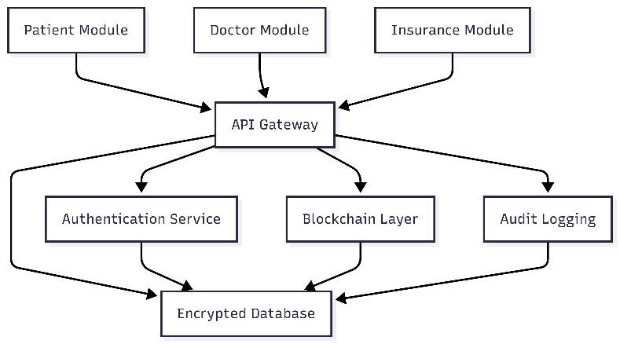
The proposed healthcare integration system is designed in distributed architecture and connected the Patient module, Doctor module and Insurance module via the API Gateway. In the system architecture diagram it shows that each module connected with the API Gateway. The API Gateway acts as the central communication layer while making sure the information transfer via a security layer and standardized protocol. The authentication service to identify the user and provide the identity management of them, encryption of database for the sake of storing the sensitive information safely, the use of blockchain layer to prevent the alteration and modification of the data, and also the audit logging mechanism for the traceability of all the transactions performed by users are included. The patient/doctor will insert the input in terms of medical report and request, in the workflow and sequence diagram it can be seen that after that the input data will go through the authentication process, validation, and encryption and stored in the system. The data can be retrieved via the API Gateway to authorized parties such as doctor and insurance based on the role-based access control. Every piece of transaction will be verified, time-stamped and delivered securely. The accuracy of the medical record can be used for clinical diagnosis by doctors. Meanwhile, insurance claim validation can be done by insurance companies using the verified record. The redundancies can be reduced.

Key Features or Functionality
Patient Module: Safe and secure profile generation through verified access, secure medical record upload using standard formats (HL7/ FHIR), instant access to reports, booking appointments and monitoring insurance status throughAPI.
Doctor Module: Instant retrieval of patient history via interoperable APIs, real time alert of allergies through rule based engines, e-prescription generation, upload diagnostic images and maintain clinical notes using standards (data models).
Insurance Module: Upload of digital policy details, claim processing through smart validation rules, checking treatment eligibility and tracking of claims in real time through API integration.
Innovation & Differentiation: While Google Health, Practo and Traditional EHR systems have created solutions with isolated views or service-specific functions, this platform has brought together all stakeholders and developed a single interoperable system. Use of standard data models and an API driven platform along with blockchain provides for secure, non-erasable and platform neutral exchange of data which solves the missing link in interoperability and single view.
System KPIs: Key targets are: 5 minute record access time, reduction in duplicate testing by 35%, reduction in errors due to documentation by 40%.

Technology / Method Used
A MongoDB is used for database as it is easily scalable, it allows heterogeneous health record like structures, images and PDFs to be stored together and supports a flexible schema. It is implemented by Node.js with express which is designed for a real-time API driven application as it has an event driven and non-blocking nature, it also complements MongoDB well.
Layering of architecture:
Frontend: patient, doctor, insurance stakeholders interface. Web/mobile are used. HTTPS communication.
Backend: node.js/express services which carries out the business logic, validation, authentication and encryption. RESTful application.
Database: Stores encrypted patients records, audit log, transaction's meta-data etc using MongoDB.
The logic implemented for security:
Data-at-rest encryption: we are using AES-256 to encrypt patient's record before it is stored in the MongoDB database.
Key Exchange: We use RSA-2048 to secure key exchange between clients and server.
Transport security: SSL/TLS used in every API communication to prevent eavesdropping and tampering.
Authentication: Muti-factor authentication is enforced to allow only the authorized people access the information.
Audit Logging: Every change/access to patient's record is logged with a timestamp and a User Identity to allow for traceable activities.
It guarantees the confidentiality, integrity and availability while system operates efficiently.

Expected Outcome & Benefits
Clinical Effectiveness Through a shortened time for data retrieval and fewer duplicate tests, the system plans to increase efficiency in the clinic. Expected Benefits –faster access to records (~60% decrease), fewer redundant diagnoses (~35% decrease), and fewer documentation errors (~40% decrease). This was achieved through simulation data of patient records and API load testing. Insurance Claim turn around time expected to decrease to ~3days via the use of the API and automatic claim validation.
KPI Measure – Retrieval time is calculated by system logs, duplicate tests calculated by the system comparison with previous entries in history records, insurance claim process from when it has been submitted to approved by the insurance and finally Documentation errors calculated by taking audits against template.
Test Plan – Unit & Integration test to ascertain functionality of modules and data process between. Performance test to simulate multiple user, identify bottlenecks for scalability. Security test to ensure Data Encryption and controlled access and log entry. User Acceptance test to ensure system effectiveness and ease of use for clinicians and insurance company.

Original Contribution Statement
This system develops its own patented, multi-stakeholder healthcare ecosystem that connects patients, doctors, and insurers with a dynamic, permissioned access model. A blockchain audit layer ensures traceability and transparency through recording all access and modifications, establishing secure, interoperable, and accountable health-related interactions that go beyond traditional hospital focused EHRs with quantifiable positive effects on efficiency and patient safety.

